Database: Collection of database Object

DB Objects:

Database

Table

Stored Procedure

Trigger

View

Cursor

Indexer

..............

SQL: Structured Query Language: Is a language: It is used to communicate with the Database

Database: Sql Server, Oracle , My Sql, Teradata, DB2, MangoDB, Postgre SQL.....

Query: it is the instruction send to the database

...........................................................

Based upon the behavior of commands categorize in to:

DML : Data Manipulation Language

DDL : Data Definition Language

DRL : Data Retrieval Language

DCL : Data Control Language

TCL : Transaction Control Language

DDL : The commands under DDL are used to perform manipulation on the object definition

Table Definition : Is noting but Table Name, Column Name, Data Types, Constraints

Data Types:

1. Int : Integer ---> It will allow only numbers ----> Limite -214 cr to +214 ---> 10
2. Char(N) : Character(N) ---> IT will allow alphabets, numbers, special characters.
   1. N -> represent the maximum number of characters allowed.
3. Varchar(N): Variable character(N)---> It will allow alphabets, numbers, special characters.

N -> represent the maximum number of characters allowed.

EX: --->

Char(10): If less than 10 characters are inserted, it will occupy 10 characters memory

Varchar(10): If less than 10 characters are inserted, it will occupy only the required characters memory and it will free up the remaining space.

1. Create: It is used to create any db object.

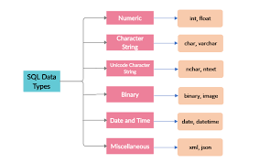

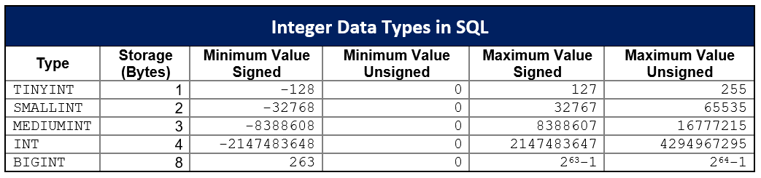

1. Alter: It is used to modify the object definition.
2. Ex: For a table, we can add a new column, remove existing column and change the data type of the column
3. Drop: It is used remove the object from the Database
4. Truncate: It is used to remove all the data from the table

..................................................................

DML Commands:

* Insert: It is used to insert the records into the table
* Update: It is used to modify the existing data in the table
* Delete: It is used to remove record(s) from the table

......................................................................

DRL Commands:

Select: It is used to retrieve/fetch the data form the table.

.......................................................................

DCL Commands: Data base administrator use these commands

* Grant: It is used to accept the request
* Revoke: It is used to remove the existing permission
* Deny: It is used to reject the request

.......................................................................

TCL Commands:

* Commit: It is used to save the transaction permanently
* Rollback: It is used to revert back the transaction
* Savepoint: It is used to save the partial transaction

…………………………………………………………………………..

DDL

DDL

1. Create command use :

A) Creation of a data base:

Syntax: create database databasse_name

Note: Do not use spaces/dot and numbers as the first character in the name

Ex: create database lokesh_01

B) Create of the table:

Definition of the table is ---> Tabel name, column name, Data types

Syntax: create table table_name(col_name1 datatype,col_name2 datatype,..,col_name datatype)

Ex: create table student_Info(std_id int, std_name varchar(30), std_loc varchar(30))

C) If you want to see the existing table

Syntax: sp_name @objname = Name of the table

D) Alter:

1. Adding a new column to the existing table

Syntax: alter table table_name add col_name datatype

Ex: alter table student_info add std_email varchar(30)

2. Removing the existing column from the table

Syntax: alter table table_name drop column col_name

Ex: alter table student_info drop column std_loc

3. Modify the data type of the column

Syntax: Alter table table_name alter column coname datatype

Ex: alter table student_info alter columnstd_email char(50)

This query also used to modify the existing data type also

E. SP_RENAME – pre defined stored procedure in SQL server. Using this we can change the table name and column name

* 1. Change the table name:
     1. Syntax: sp_rename ‘table_name’ , ‘new_table_name’
        1. Ex: sp_rename ‘Lokesh_01.student_info’ , ‘student_information’
  2. Change the column name:
     1. Syntax: sp_rename ‘table_name.colunm_name’ , ‘new_col_name’ , ‘column’
        1. Ex: sp_rename ‘student_information.std_email’ , ‘student_email’ , ‘column’

F. Drop: It is used to remove the DB object form the database

* 1. Drop a table:
     1. Syntax: drop table table_name
        1. Ex: drop table student_information
  2. Drop a data base:
     1. Syntax:drop database database_name
        1. Ex: drop database Lokesh_01

G. Truncate: It is used to delete all the records form the table

Syntax: Truncate table table_name

Ex: truncate table student_information

1. NOTE: Once the creation of database is successful, internally in the system two files will be generated.
   1. .mdf: Master Data File – It will store all the object information and data
   2. .ldf: Log Data file – it will store the transactional information like who created the object, who modified the object, when the object is created, when the object is modified…
2. MDF will be divided into extents
3. Each extent is divided into pages
4. The table structure, data inside the table will be stored in a page
5. Truncate command will delete entire page and recreates the page with the same table structure

DML

Insert: It is used to insert the data into the table

Syntax: insert into table_name value(value1, value2,…..,value N)

Rule: The values must be passed in the same sequence if the sequence of the table definition